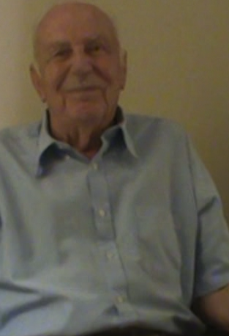
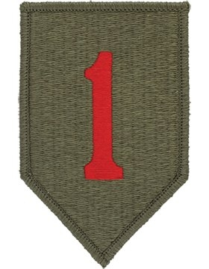
BILL FUNKHOUSER
1st INFANTRY DIVISION
&
D-DAY VETERAN

A MIS-MATCH COULD NOT STOP HIM
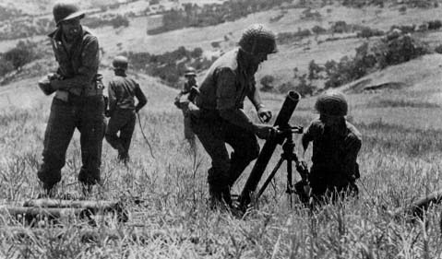
“I Completed my basic training at Camp rewood in Georgia – 13 weeks, it consisted of physical training, M1 rifle training etc.”. “Then I shipped out to Norfolk and then to Casablanca
I was assigned to the mortar squad without any formal mortar training since I only had a short time to train, in fact I had never seen a mortar before”.

THE BATTLE OF NORMANDY
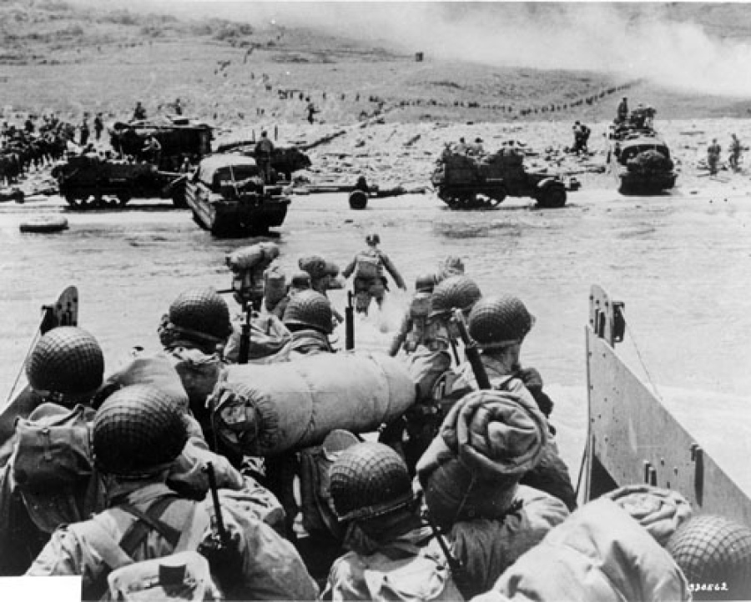
“We left for Normandy the evening of June 5th, we were given a light meal, because the carnage was sure to be sickening. We were in the landing barge and landed at Normandy at 6:35. When the ramp dropped I was half way back, I jumped off to the side, got really wet and he ran to the beach and I was chased by the pillbox guns as I was crawling. I grabbed a comrade Houston Reily out of the water who would later be shot that day”. “F company headed up the beach, up a hill and to a tree line with no brush, at this time I had left his mortar on the beach since both ammunition men were killed, an officer suggested that I trade his 45 pistol for an M1 rifle, so I did”. “Me and another soldier were tasked with drawing the fire away from the company, when doing this I lost his rifle and my water canteen was hit by a bullet, I thought he was hit, but I did not panic”. “My company had pulled back after suffering losses and I was under-equipt with his comrade I reunited with F company and we dug in at their position in a field, the 1st sergent was leading the company since the captain was hit. My First night in France, I slept in a ditch with a gas mask and no weapons.” “By the time I woke up the next day the allies had taken the ground and I got a cup of coffee from a truck that passed by, it was the best coffee I ever had in my life”.

BATTLE OF THE BULGE
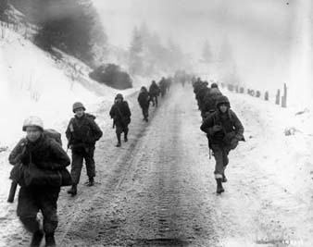
“After moving from Aachen the 1st Infantry moved to Belgum after they sent some of the company to Belgum for 4 days. Soon the Infantry moved back into Belgum and I joined them,we were preparing to enter the Battle of the Bulge”. “We got to this town in the region it was empty until you went to the top of the hill and then you would see the battle, we would spend christmas at this town”. “When it got into January both the snow, and the fighting began to ramp up, the cold was not an issue the main goal was to survive”. “A few soldiers struggled with post traumatic stress that day, soldiers would throw down their guns and helmets saying their done”.

END OF THE WAR
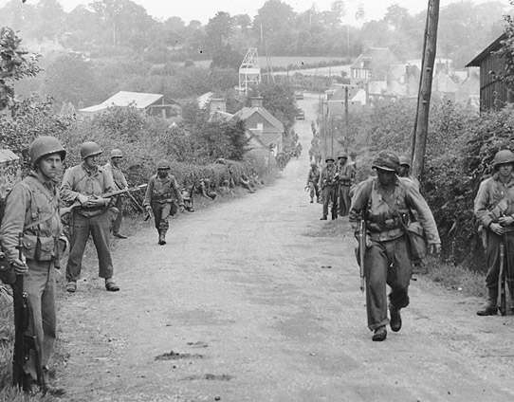
“By the time the war had ended Iwas in Czhekoslovakia when they heard the war could be over we were not celebrating by then it was was May 7th or 8th of 1945 I had the points to be discharged and I was sent to 9th Armored Division to go home”. “The towns folk are more relieved the war was over, just like most people all over the world”.

REVIEW OF SERVICE
“I was happy that my actions were remembered as long they don't do it again, he a a good many friends throughout his time in the service some made it through the war when others did not”.

